**USE OF CFWC / GFWC LOGOS and MOTTOS**

Federated clubs and districts are allowed to use these logos and mottos (“Marks”) in marketing, fundraising, and publicity materials under a **non-exclusive, royalty-free, limited license**. Each logo or motto can be used separately or appear together. Use of one does not require the other; although clubs are encouraged to promote affiliation with both entities.

**Definitions**

* **“n*on-exclusive*”** means all eligible clubs and districts can use the Marks at the same time and for similar purposes.
* **“r*oyalty-free*”** means there is no fee (royalty) paid to CFWC or GFWC when a club or district uses the Marks in an approved manner.
* **“l*imited license*”** means there are limits to and restrictions on using the Marks:

**Restrictions**

* Marks can be enlarged or reduced in overall size; but cannot be otherwise altered or reshaped.
* Marks can appear in black/white or color, but color cannot be changed.
* Motto must be used in complete form. No additional words or punctuation can be added. No words can be removed.

**Additional Trademark Use Information**

See last 2 pgs of GFWC *Style Guide* (GFWC.org - *Member Portal Digital Library - Resources* folder)

**[Right click on a logo below to capture and copy]**



CFWC motto:

**STRENGTH UNITED IS STRONGER®**

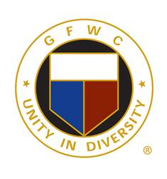 GFWC mottos (2):

**UNITY IN DIVERSITY®**

**LIVING THE VOLUNTEER SPIRIT®**